**Real Time Heart Beat Monitoring System**

**Purpose:-**

The design and development of wearable biosensor systems for health monitoring has garnered lots of attention in the scientific community and the industry during the last years. Mainly motivated by increasing healthcare costs and propelled by recent technological advances in miniature bio sensing devices, microelectronics and networking system, the continuous advance of monitoring sensor-based systems will potentially transform the future of healthcare by enabling proactive personal health management and ubiquitous monitoring of a patient's health condition In order to evaluate the heat rate and pulses in wearable health-monitoring systems, a set of significant features, that best describe the functionality and the characteristics of the systems, has been selected to derive a thorough study.

**Scientific Principle Involved:-**

In order to calculate the heart rate, based on the blood flow to the fingertip, a heart-rate sensor is assembled with the help of pulse sensor for monitoring the heartbeat pulses.

Initially, when the heart pumps blood through the blood vessels, the finger becomes slightly more opaque; due to this, less amount of light reaches from the LED to the detector. With every heart pulse generated, the detector signal gets varied. The varied detector signal is converted into an electrical pulse. This electrical signal gets amplified and triggered through an amplifier which gives an output of +5V logic level signal. This variable signal is computed as input for the microcontroller and further algorithm is came into action to convert it into the waves of variable amplitude depending upon the input signal. These waves are shown by the computer display ,which is sent through microcontroller over the USB serial interface.

**Material’s used:-**

Android UNO R3

Pulse Sensor

Jumper Wires

Battery

BreadBoard

Soldering iron/wire

Double Sided Tape

Acrylic sheet

Velcro

USB wire

3d printer

Arduino IDE(Backend Software)

Processing Software (frontend software)

Time for Coding…..

**Construction:-**

Wearable systems for continuous health monitoring are a key technology in helping the transition to more proactive and affordable healthcare. They allow an individual to closely monitor changes in her or his vital signs and provide feedback to help maintain an optimal health status. The integrated system of pulse sensor connected to the microcontroller over the jumper wire , computer connected to controller over the USB serial interface communicating to each other and whole setup is powered by 9v battery for health monitoring of patients in ambulatory settings. For example, they can be used as a part of a diagnostic procedure, optimal maintenance of a chronic condition, a supervised recovery from an acute event or surgical procedure, to monitor adherence to treatment guidelines (e.g., regular cardiovascular exercise), or to monitor effects of drug therapy.

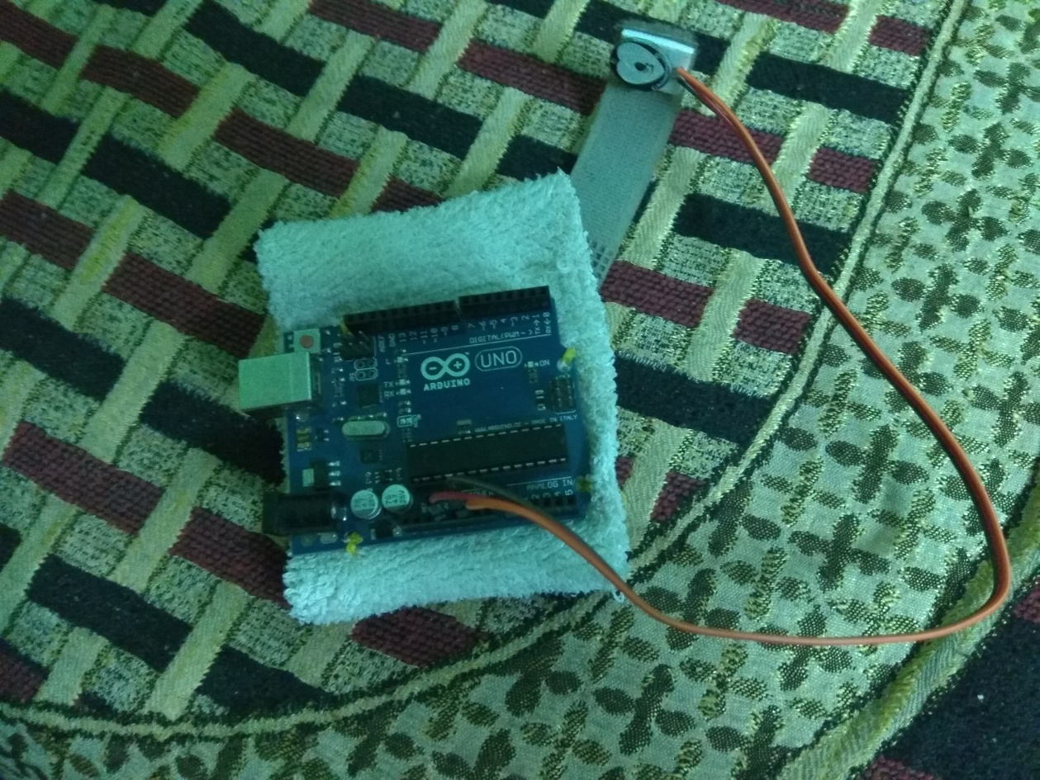

Data processing and analysis are performed on the basis of algorithm the study behind cardio-vascular system and turned them into the codes using Arduino IDE and processing Software for computer console interface.

**Working:-**

The cardio-vascular signal is a fundamental vital sign used for assessment of a patient's status. Additionally, these signals provide a great deal of information to healthcare providers wishing to monitor healthy individuals. The pulse sensor system allows the measurement of the heart beat movements on the subject's body. The +5V variable Signals from the pulse sensor is act as the input for the microcontroller on which further data processing and analyzing performs depending upon the algorithm. And these signals, which have been converted into waves, are sent to the computer console through the USB serial interface.

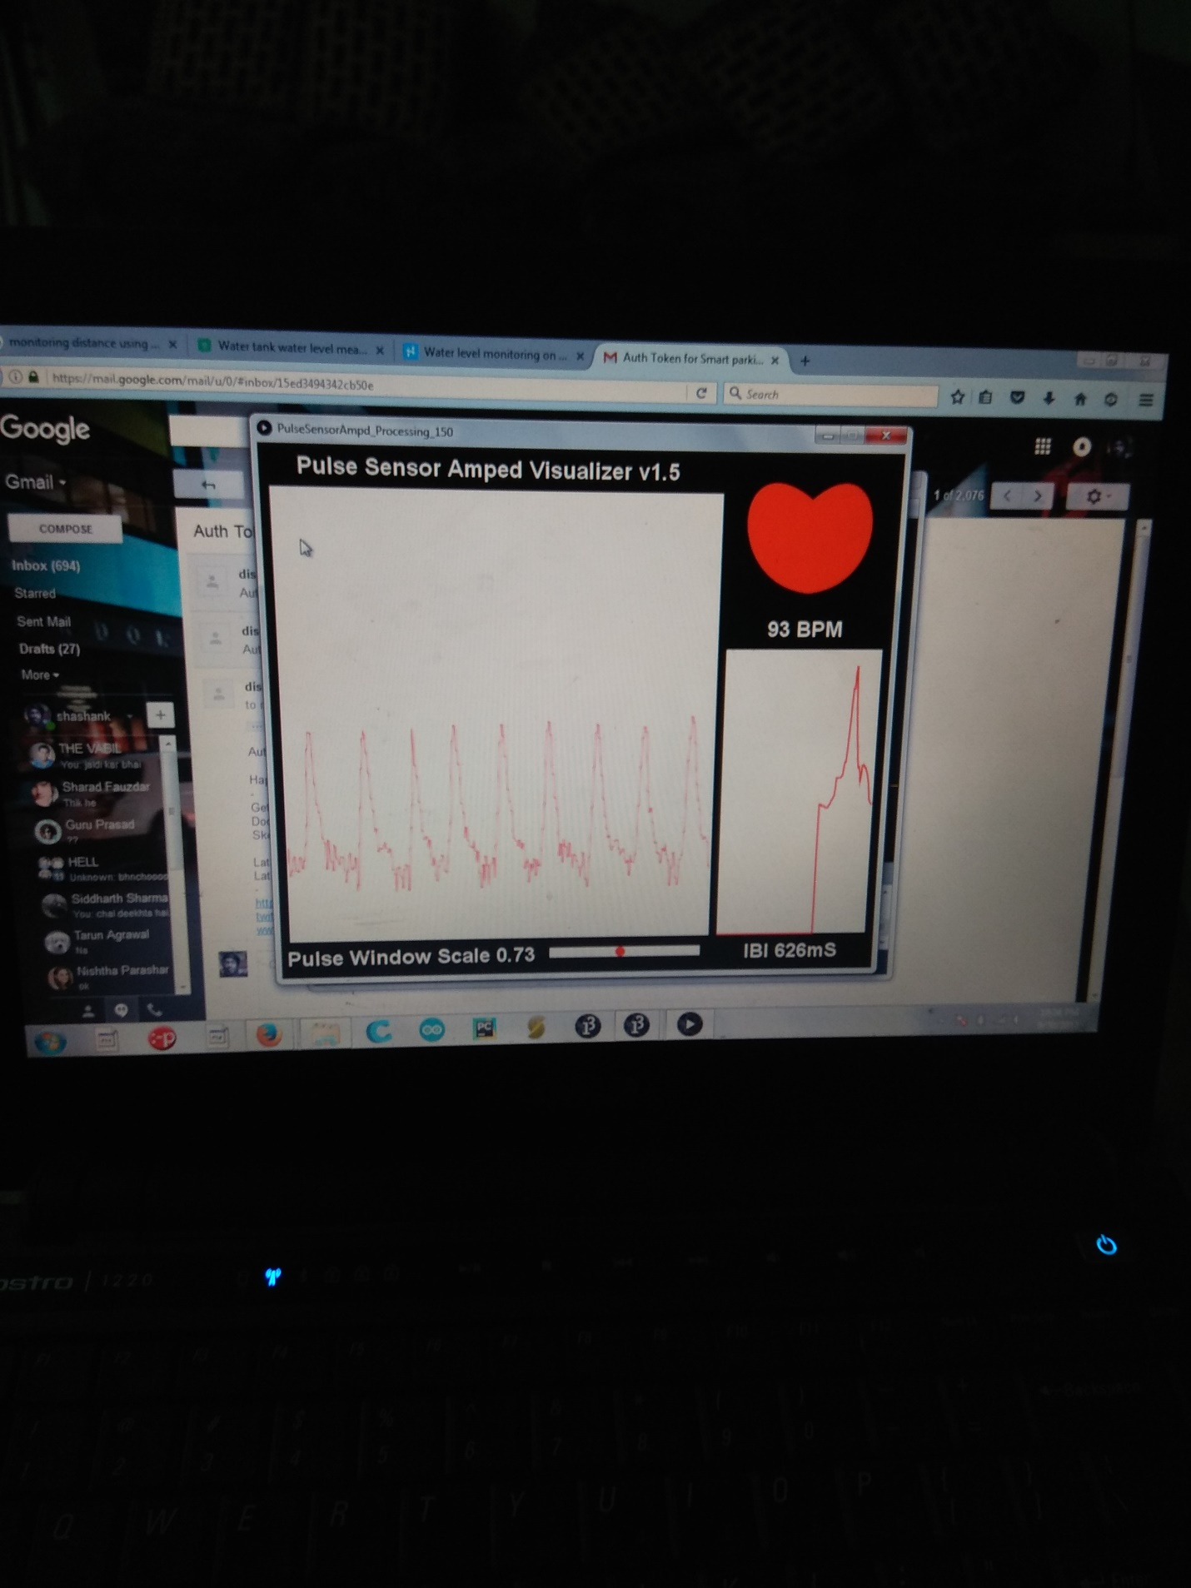

**Applications if applicable:-**

Our project generally focused on the old age people because of the weak cardio-vascular system.

Other Fields of applications are also finds it’s important in , hospital and dispensaries ,At home, emergency situations in public market, aircraft, railways etc.

**Black and White line and labeled Diagram:-**

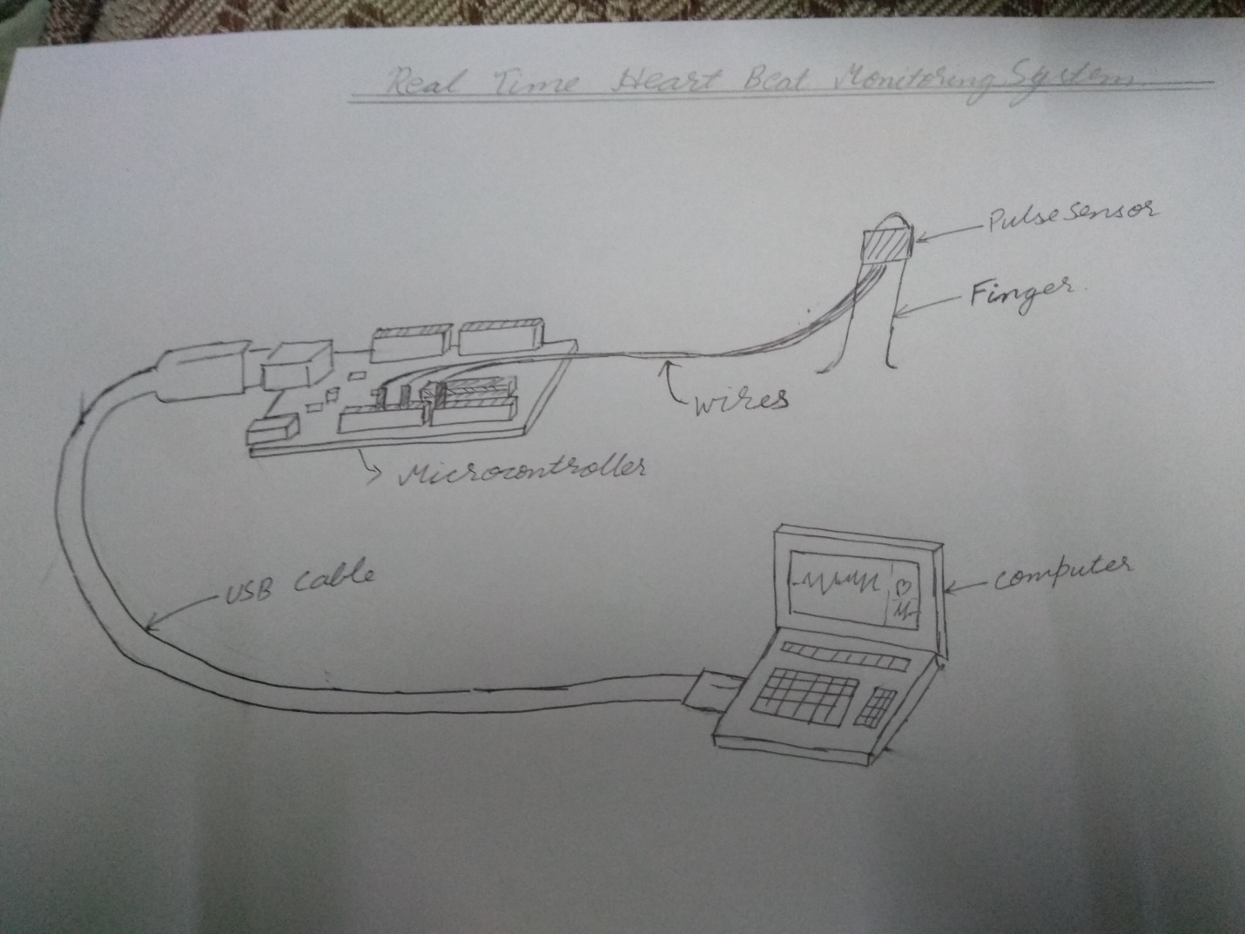

**Close –up photograph of model:-**

